Lab # Kernel Debugging — Assessment Worksheet

**Course Name and Number: IAM302**

**Student Name: Tran Thanh Tuan**

**Student Id: SE161095**

**Instructor Name: Vu Duc Ly**

## **Setting Up Kernel Debugging**

***Setting Up The Virtual Machine***

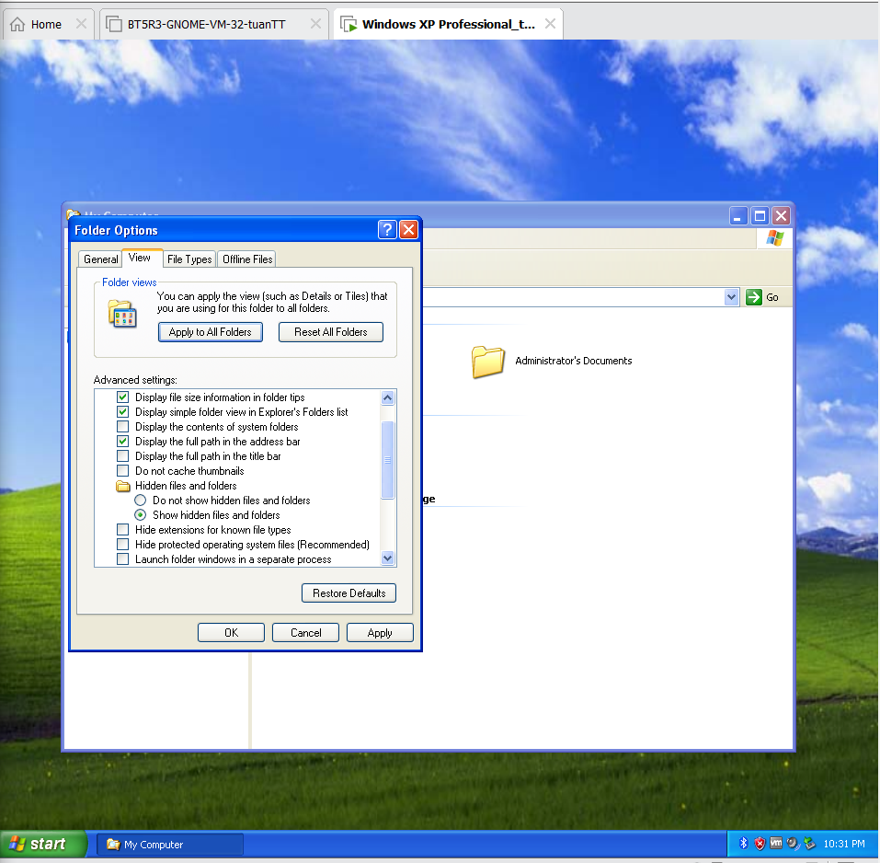

***Taking a Snapshot***

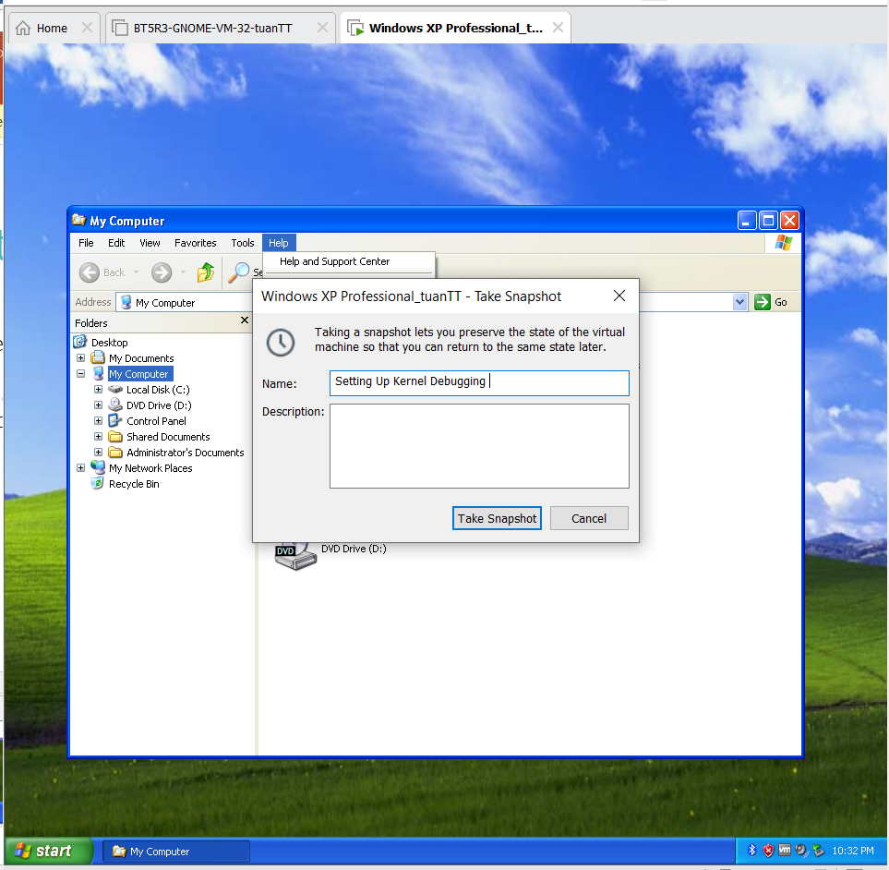

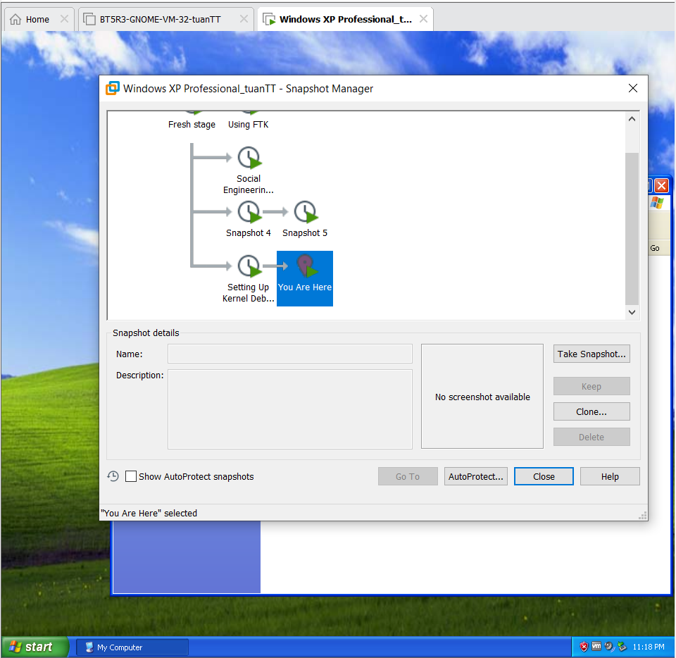

***Editing C:/boot.ini***

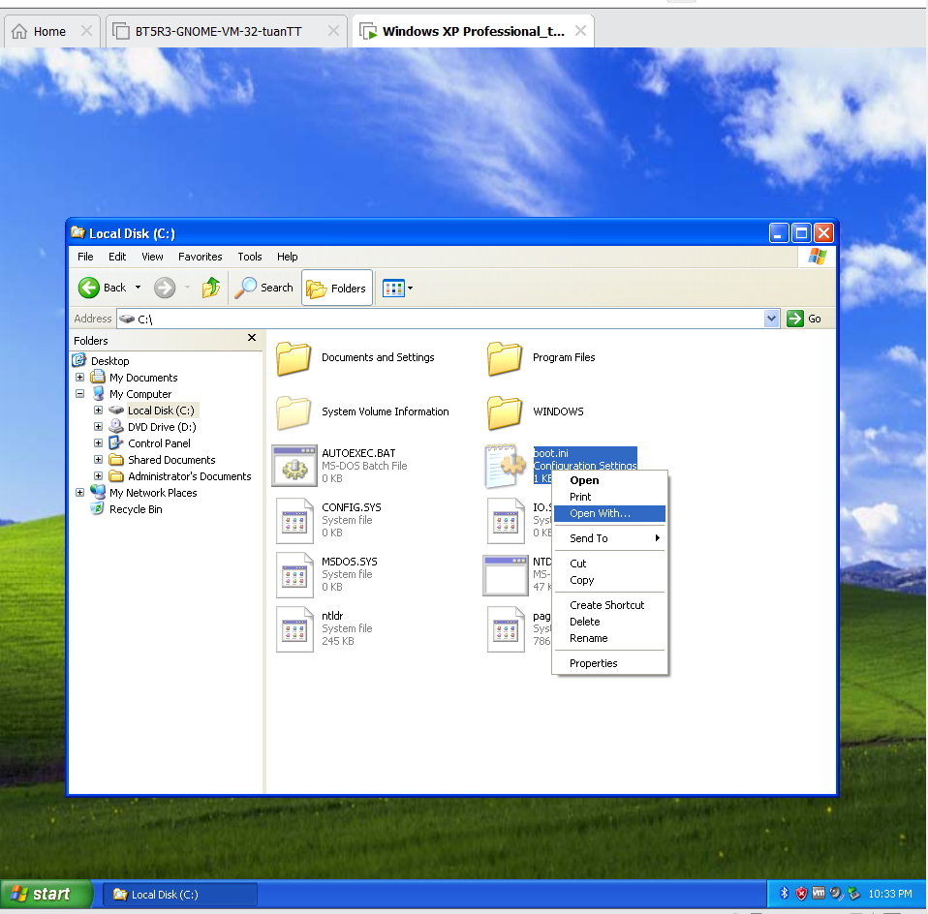

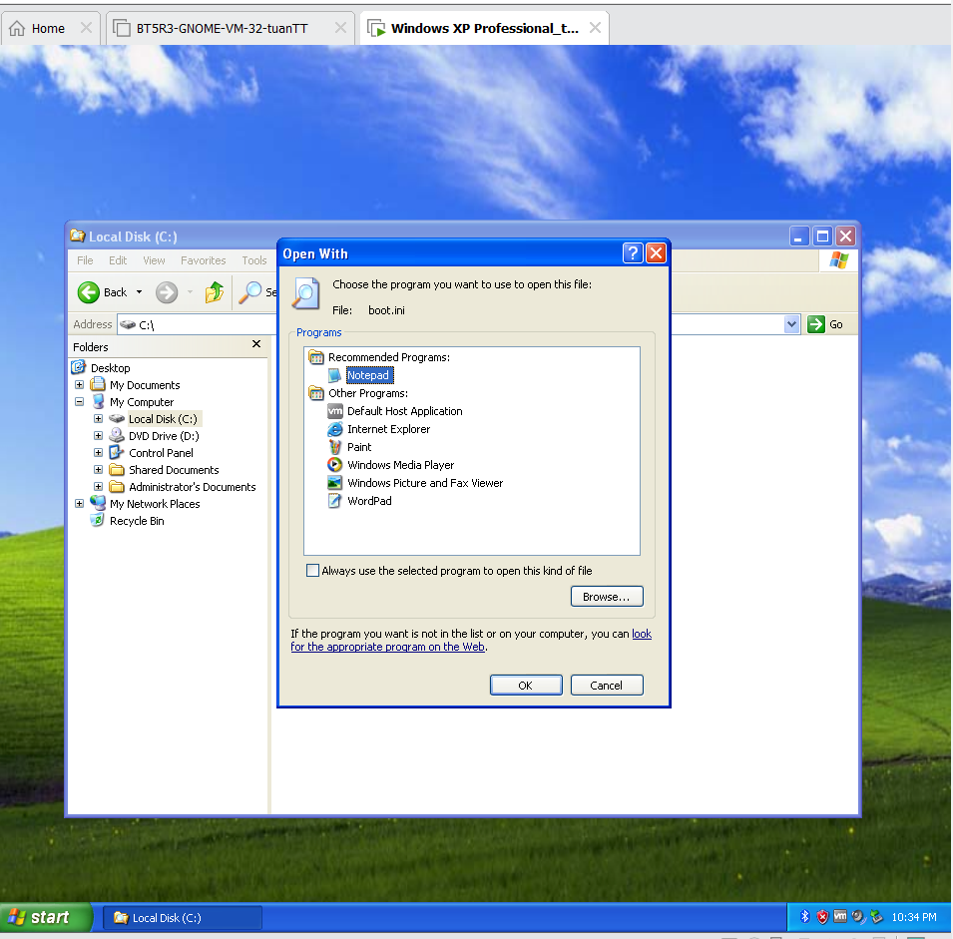

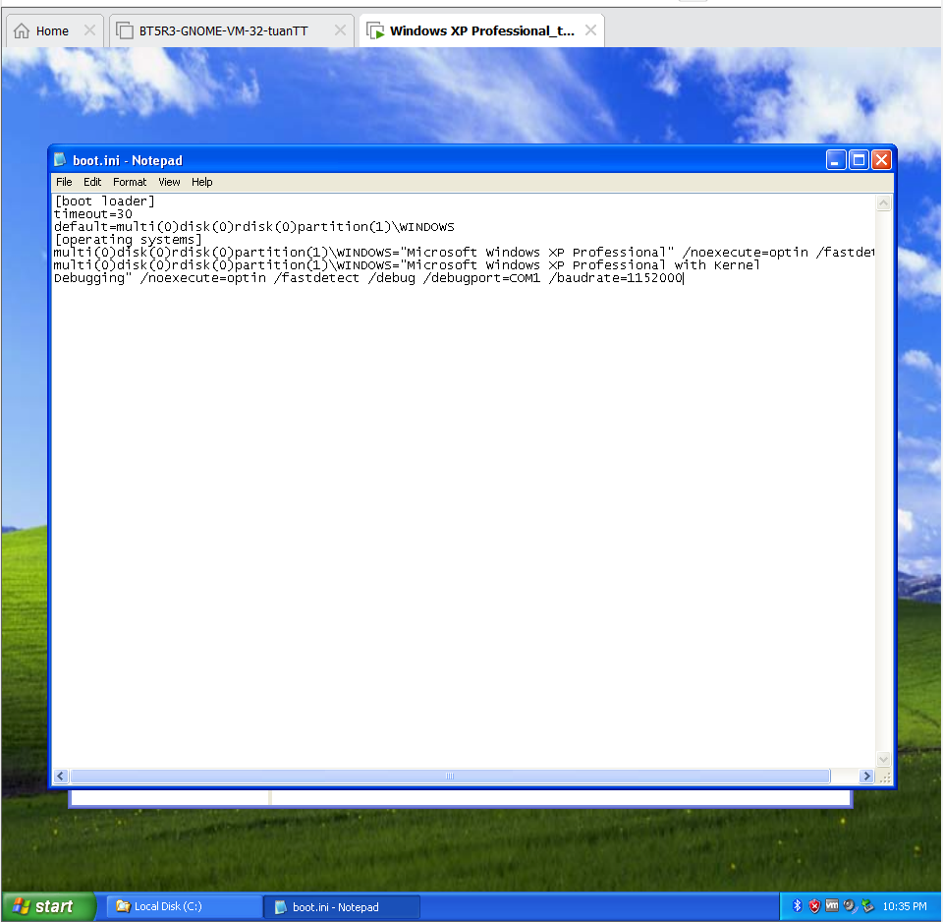

***Connecting the VM to the host***

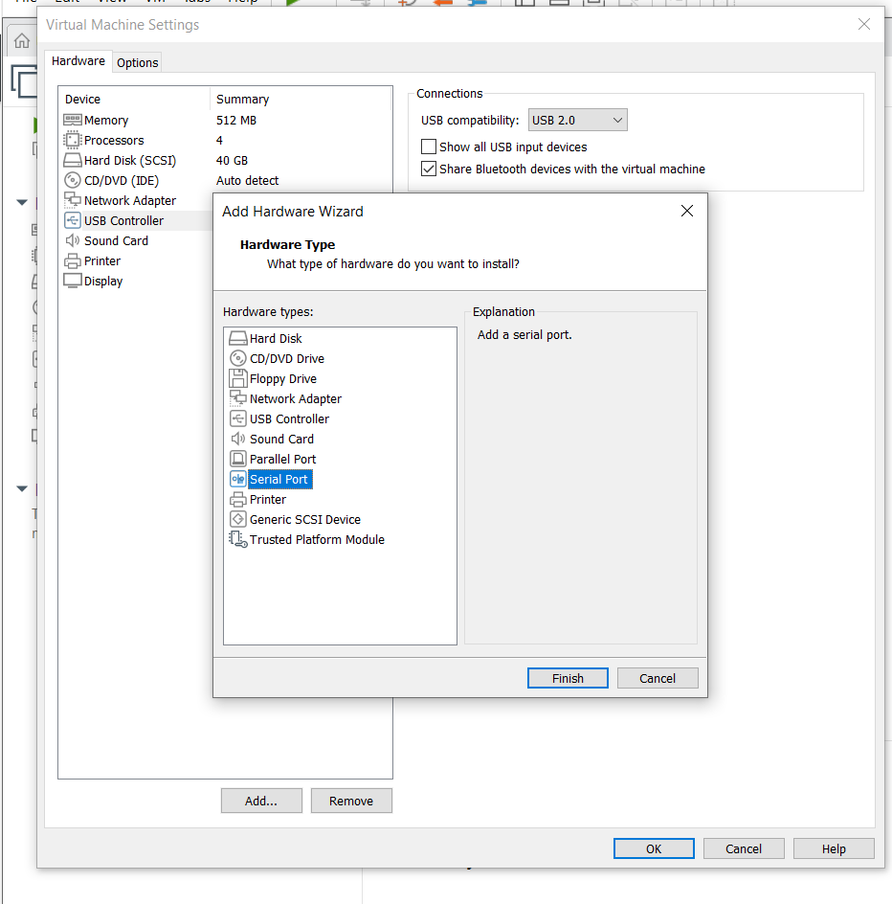

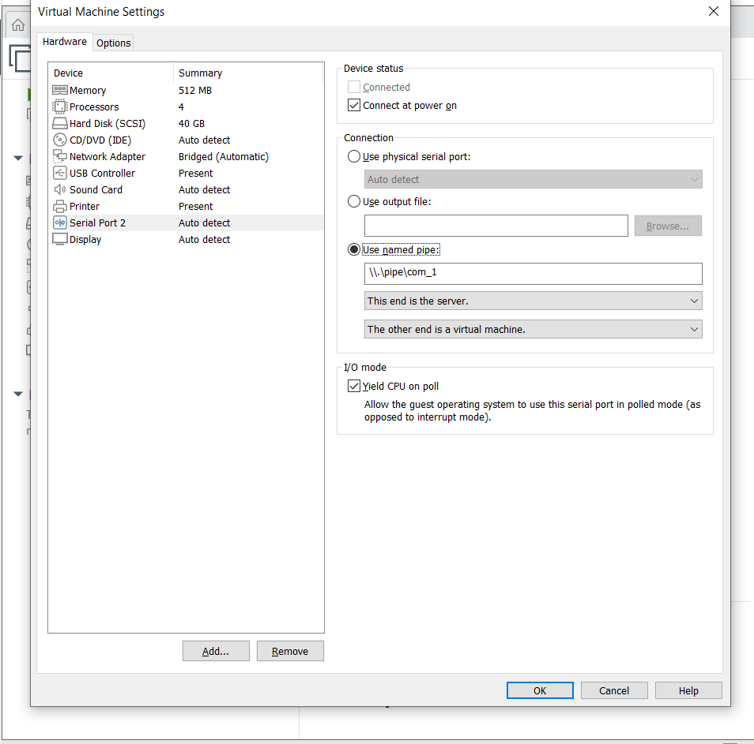

***Rebooting the VM***

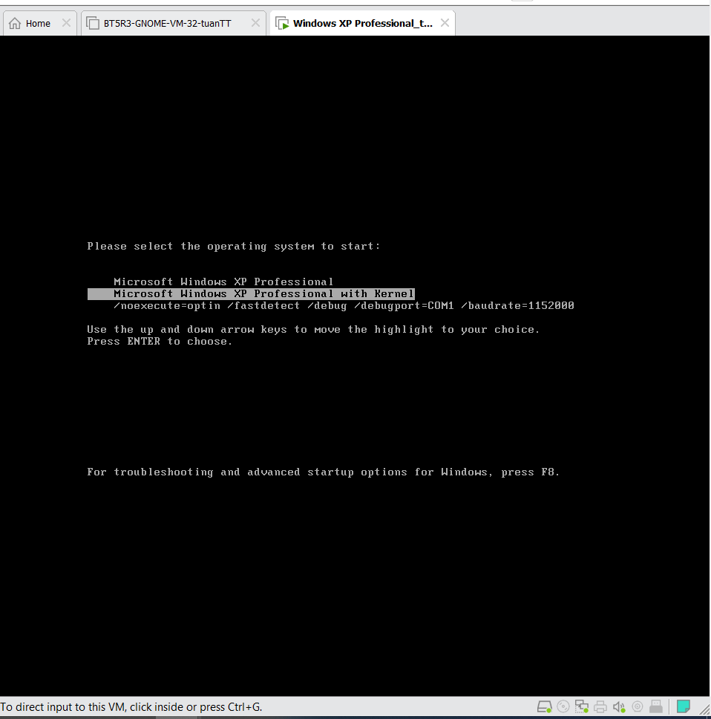

***Using Windbg***

